COMP 306 – API Engineering and Cloud Computing

Assignment 03

Group Members:

Smriti | Sruthi Sugumaran - 300983145

Screenshots:

Step 1: Deploying the app on Elastic Beanstalk

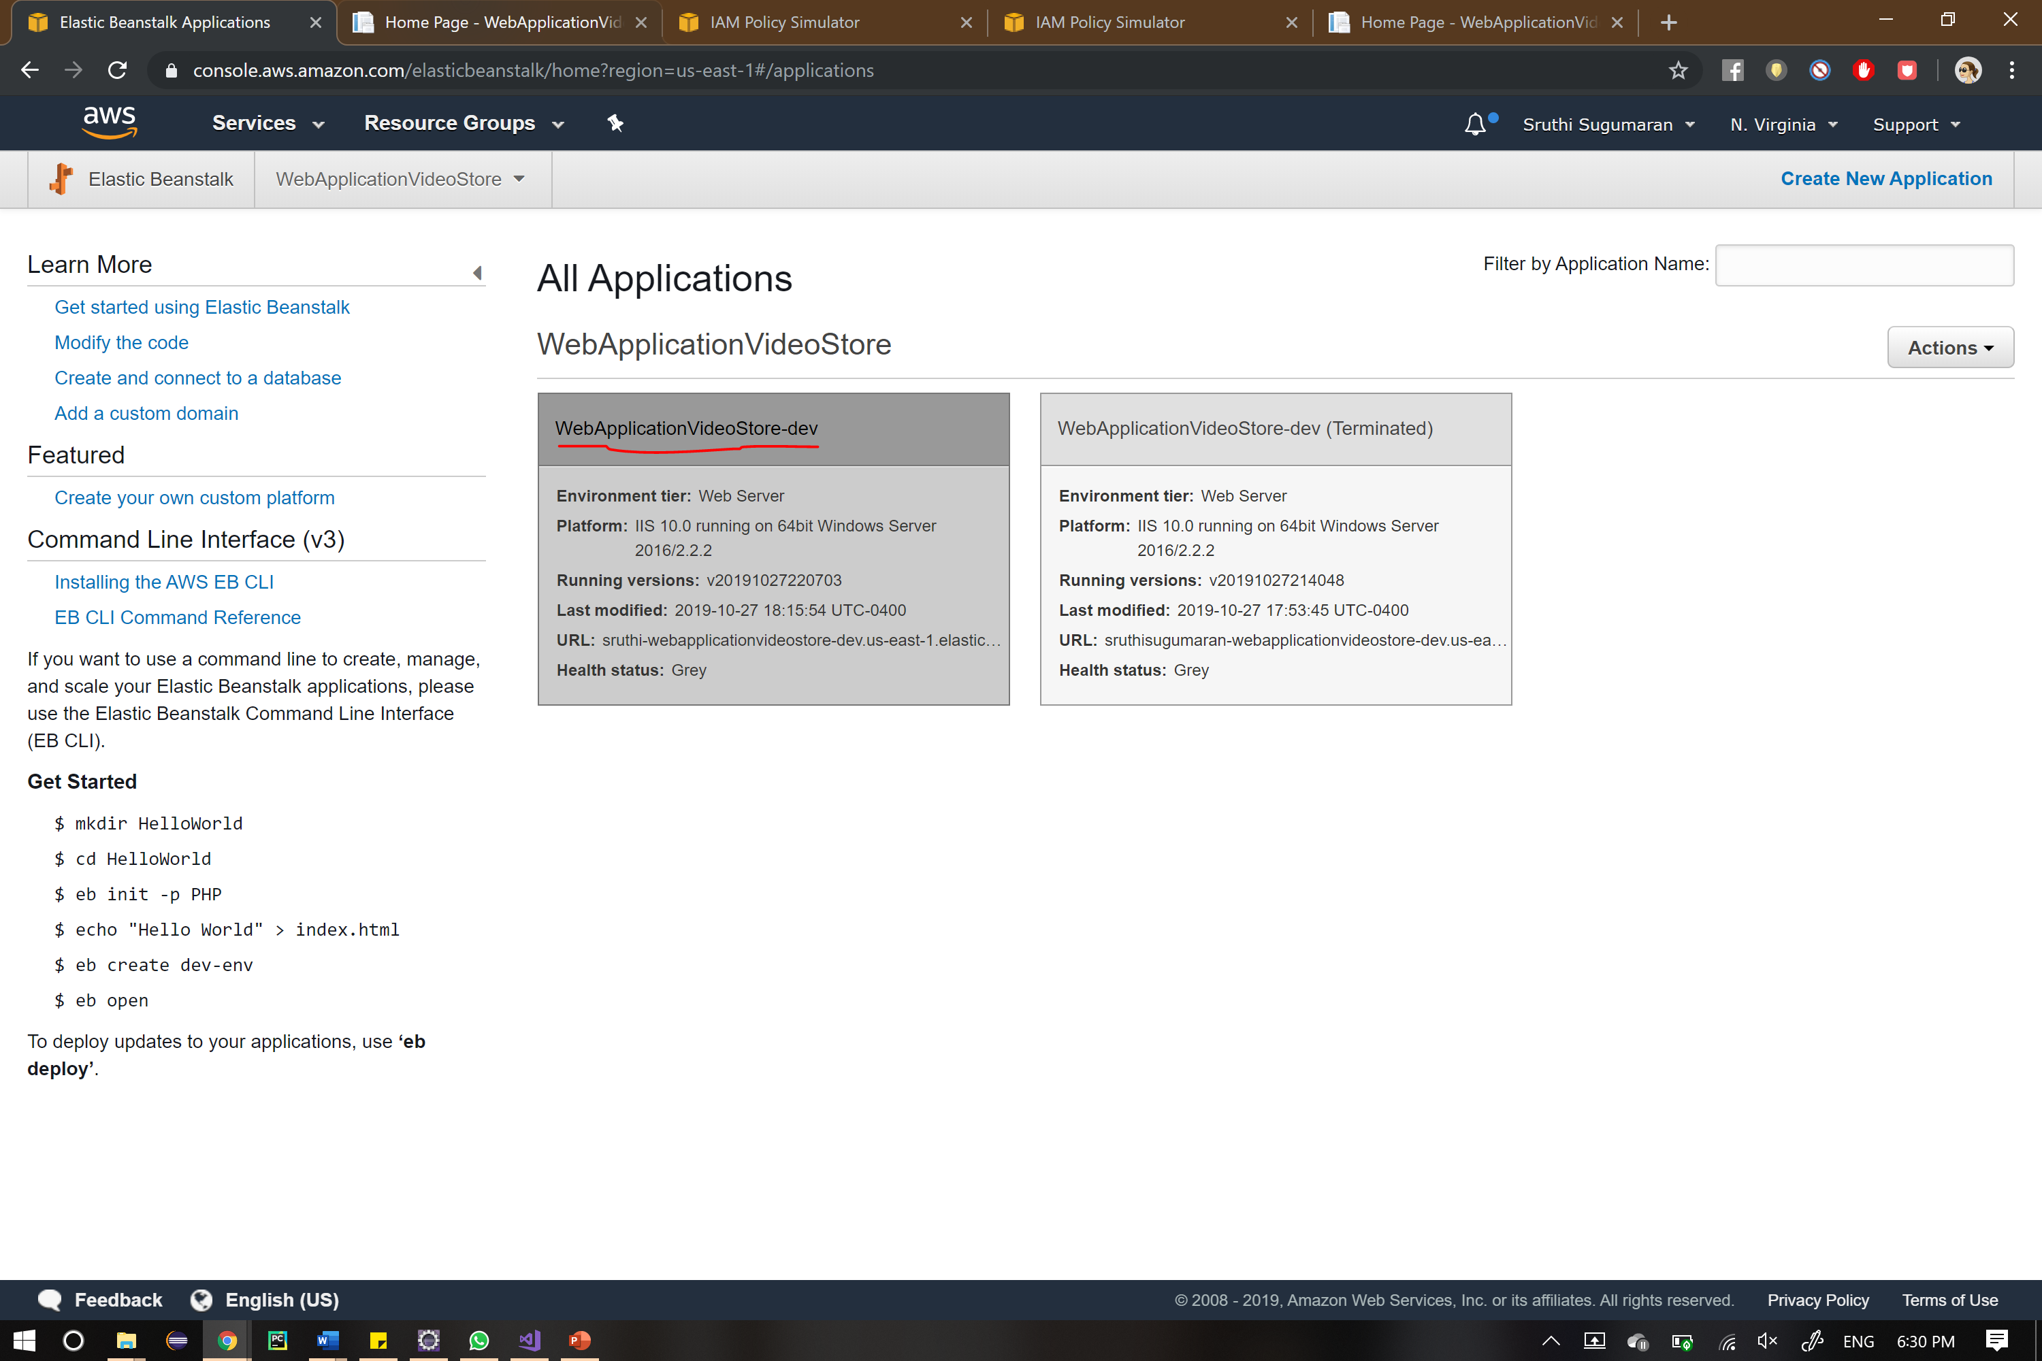

Step 2: Launching the app through the url (<http://sruthi-webapplicationvideostore-dev.us-east-1.elasticbeanstalk.com/>)

Index page automatically views all the videos uploaded by different users. Users who have not signed in can only view and play the video. They cannot upload or download it.

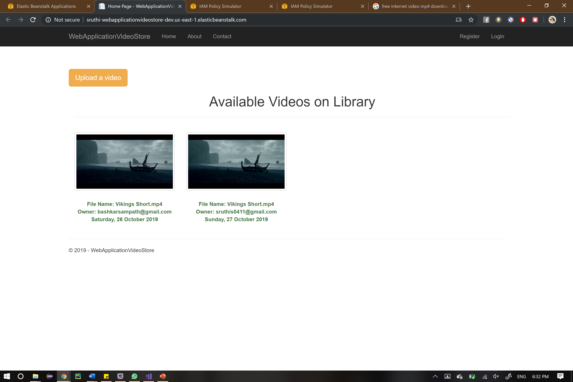

Step 3: Register Page

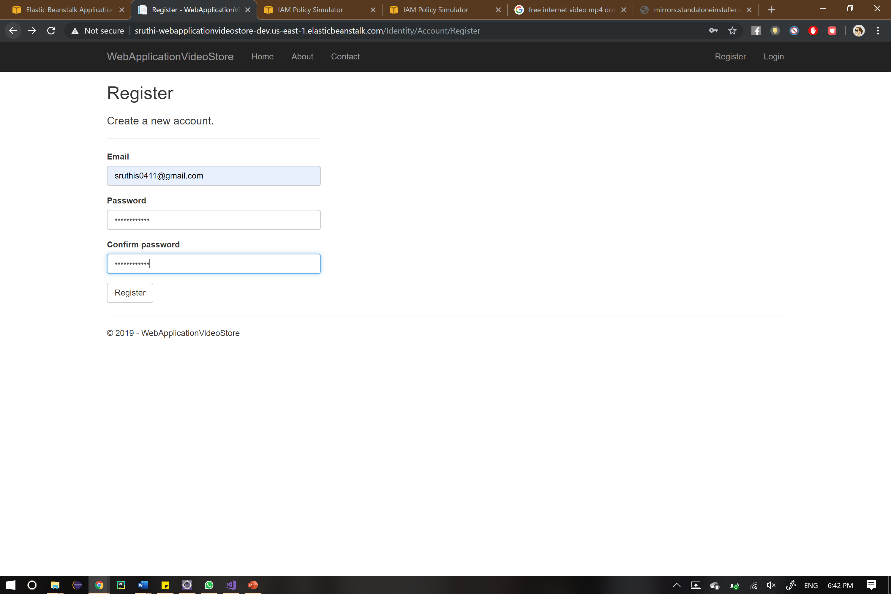

Step 4: Sign in/Log in page

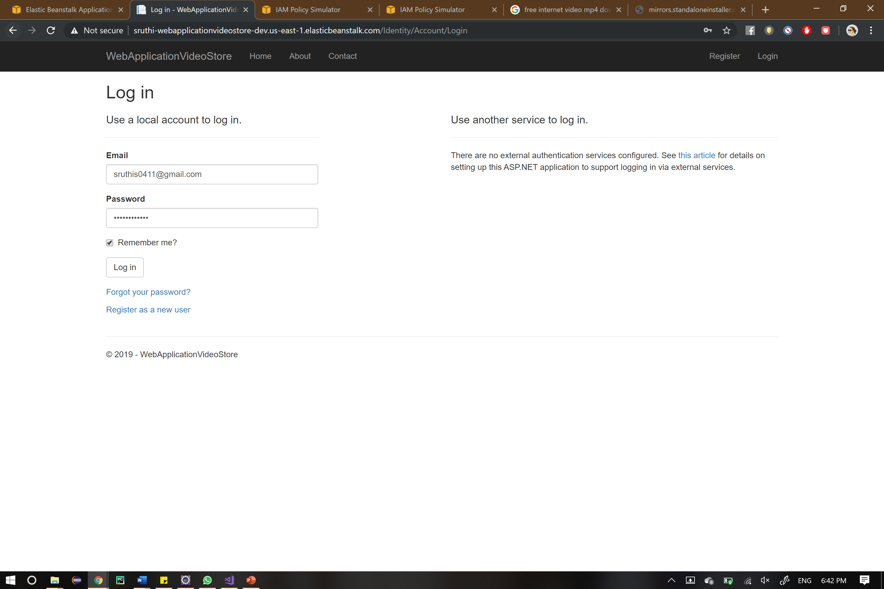

Step 5: Index page after logged in

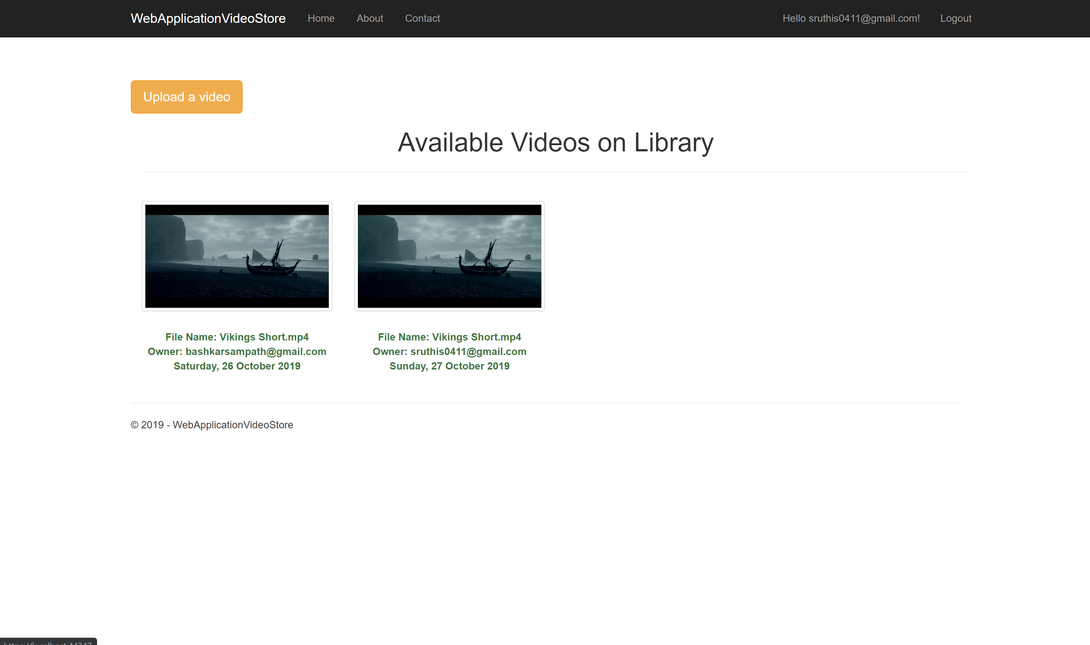

Step 6: On clicking the video thumbnail. Registered users can download video, add & view comments and rate the video.

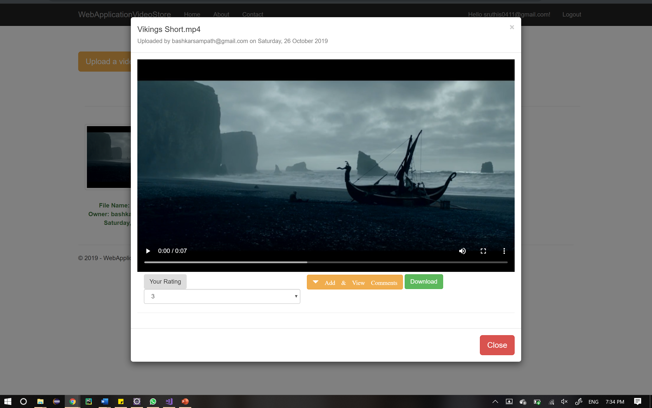

Step 7: Adding comments

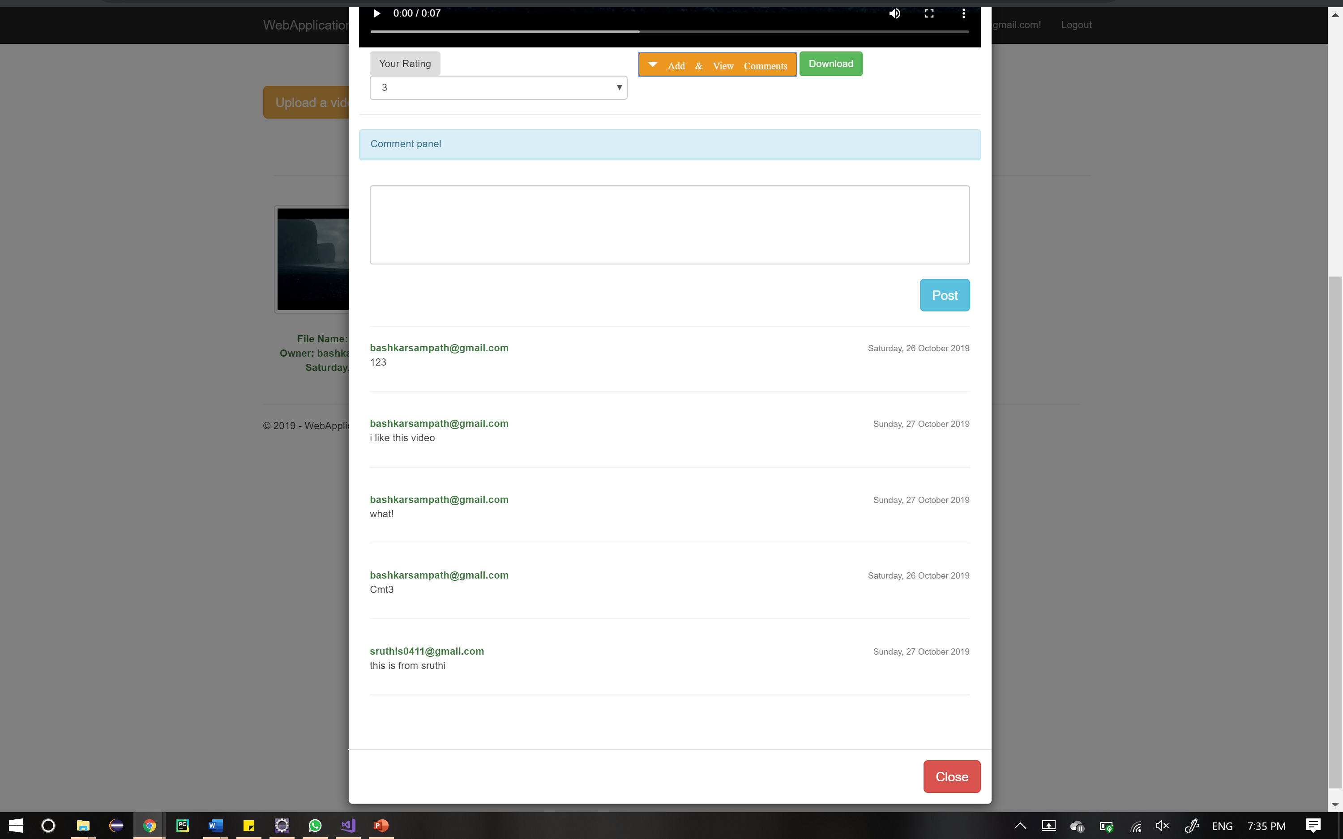

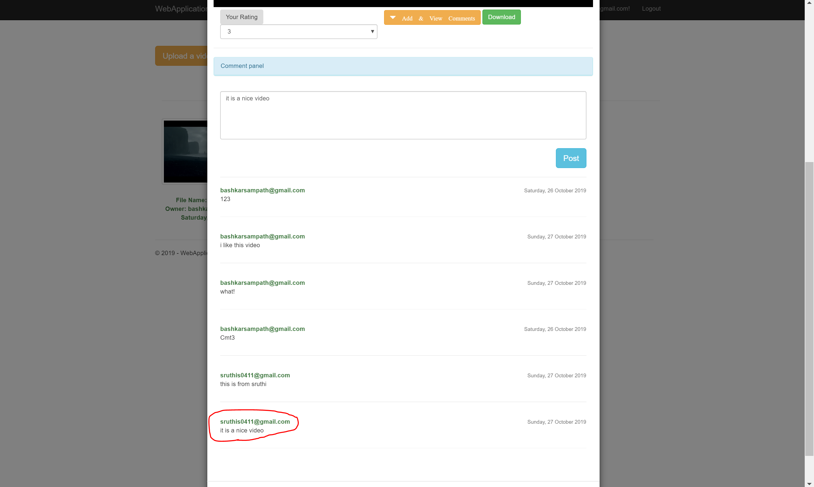

Step 8: Uploading a video

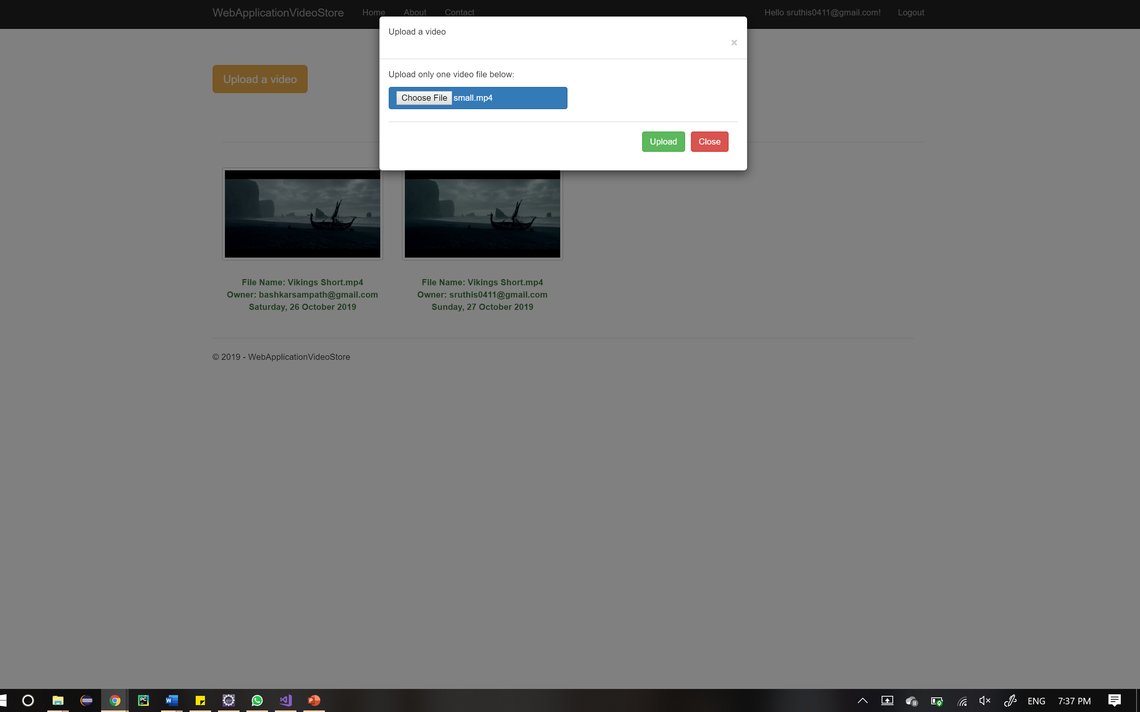

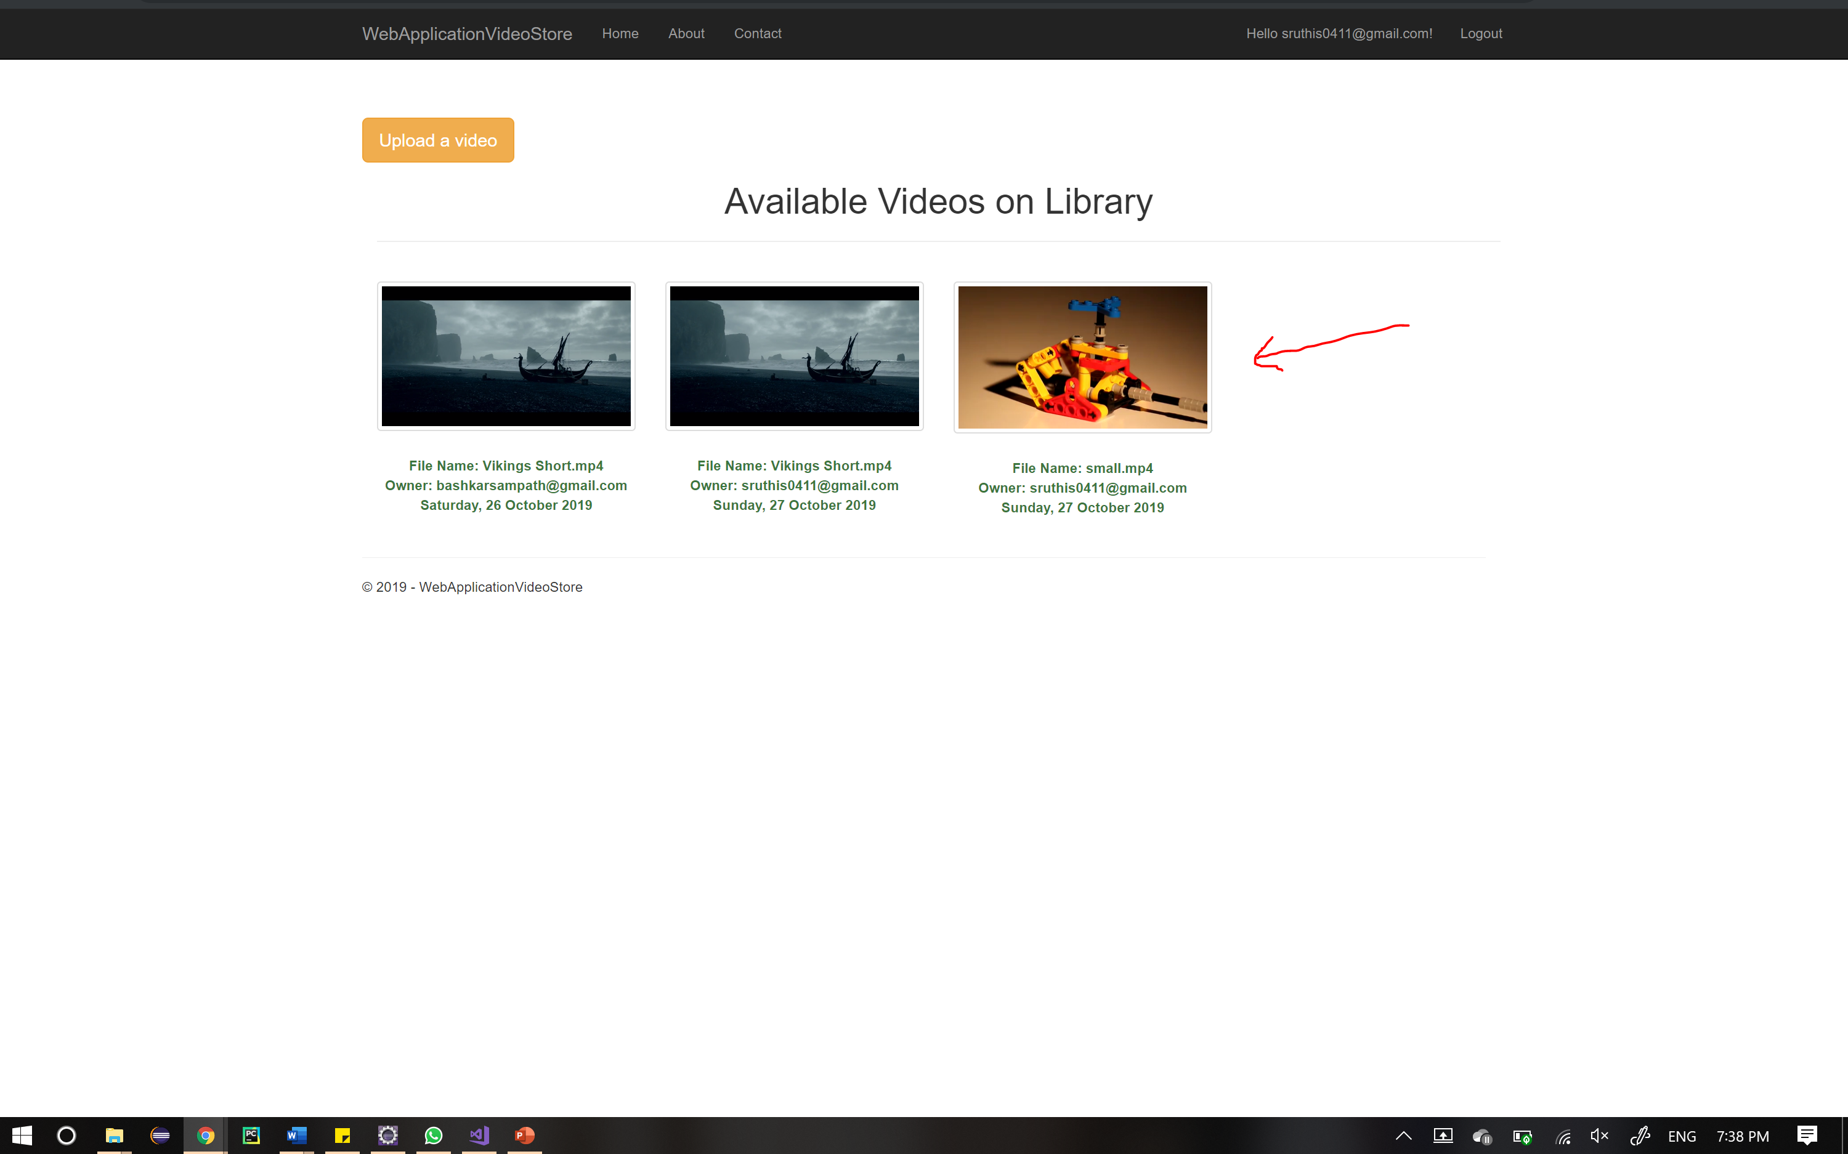

Note: Users who have not signed in cannot upload videos.

